Hong Kong – Number Porting and Allocation Form
How to fill the Number Porting and Allocation Form for installation country Hong Kong

Why do I need it?
According to the Hong Kong regulation if you want to port numbers or number ranges or want to get new numbers in Hong Kong you must fill the Number Porting and Allocation Form (Page 2).
It is critical that you provide the correct data,
otherwise, your order may be rejected,
and this will cause a significant delay in delivery.

How do I fill it? – Format instructions
- Please use the below template, without changing the format if possible.
- Please note that all Grey highlighted information is mandatory. Please fill all of them.
- Please upload in .doc, .docx or .pdf format.
- Please name it: <company name>_NPF.pdf

What should I enter? – Content instructions
- Name of the Hong Kong registered subsidiary: You should have a subsidiary with Hong Kong Business registration. This Business Registration does not have to be under the same company name you signed a contract with BT with. If it has a different name, you must indicate it in the below form.
- Business Registration Number: The business registration Number can be found on the Business Registration Certificate. If you cannot find this certificate, you can also use the following website: https://etax23.ird.gov.hk/ird/login/jsp/LandingPage.jsp (click on ‘Business Registration No. enquiry & supply of information’ on the right side panel; click on ‘Begin application’)
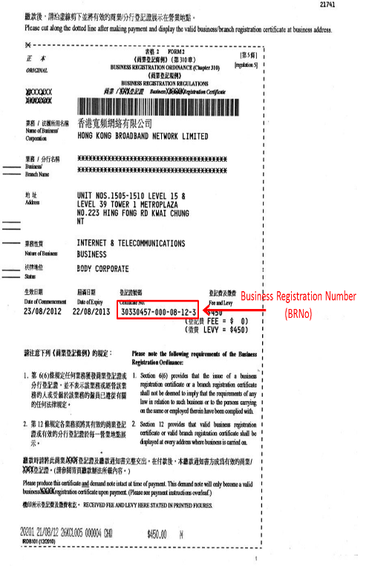

Hong Kong Number Porting and Allocation Form

Customer Information
Name of the Hong Kong registered subsidiary: |  | Company Name
Business Registration Number of the subsidiary (BRNo): |  | XXXXXXXX
Customer Site Information (please enter the details of the customer site, where you will be using the numbers from)
Site address line 1: | Address 1
Site address line 2: | Address 2
Town: | Town
Post Code: | Post Code
District: | District
Numbers
How many numbers do you request: | XX

