Attachment of Portability Port 24 hrs V.2

Request form for portability of telephone number (s) applicable to legal persons and natural persons requesting the carrying of non-geographic numbers or retrieval of numbers.

This format may be adjusted by each Service provider as long as it does not delete the information which it contains.

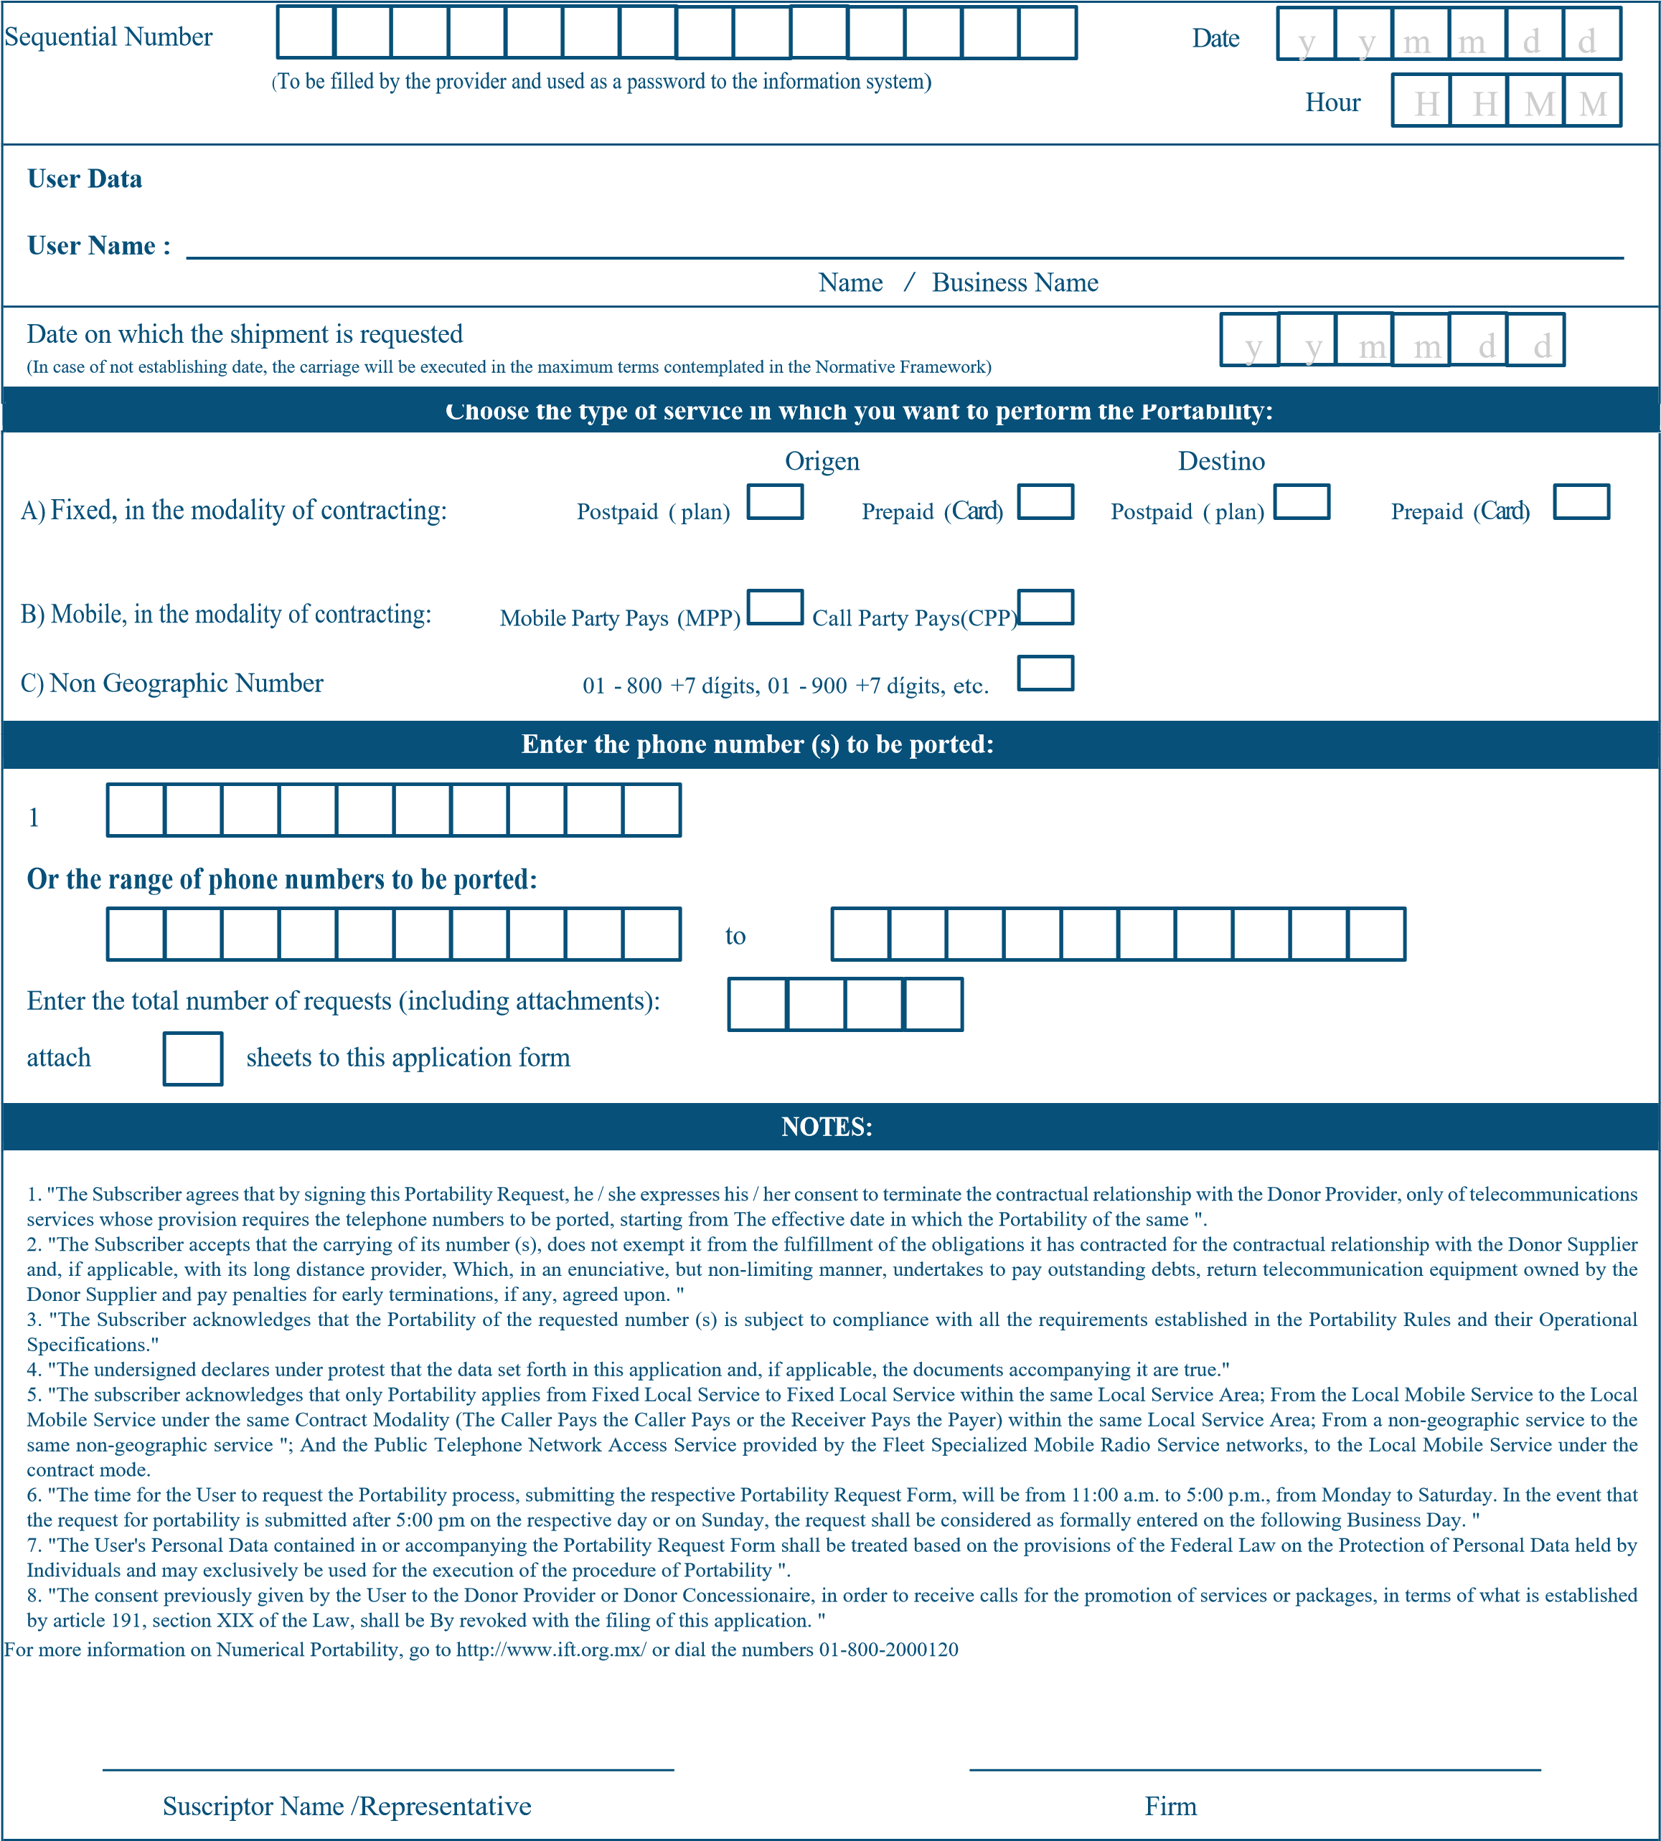
USE THIS BOX IF YOU HAVE MULTIPLE SHEETS
DATE YOU ARE REQUESTING THE ORDER TO PORT: -

ZOOM CUSTOMERS PRINTED NAME
ZOOM CUUSTOMERS SIGNATURE
ENTER A SINGLE NUMBER
OR ENTER THE RANGE OF NUMBERS IN THE TWO BOXES
WHO PAYS FOR THE CALLS?
(ORIGIN OR DESTINATION)

WHEN DO THEY PAY?
PREPAID(CARD) -OR-
INVOICED
(POSTPAID)

<CHECK ONE BOX>

WHAT TYPE OF # ARE YOU PORTING?
A) LANDLINE, OR
B) A MOBILE # OR
C) TOLL-FREE #

<CIRCLE ONE>

THE NAME YOUR CURRENT CARRIER HAS ON FILE/RECORD
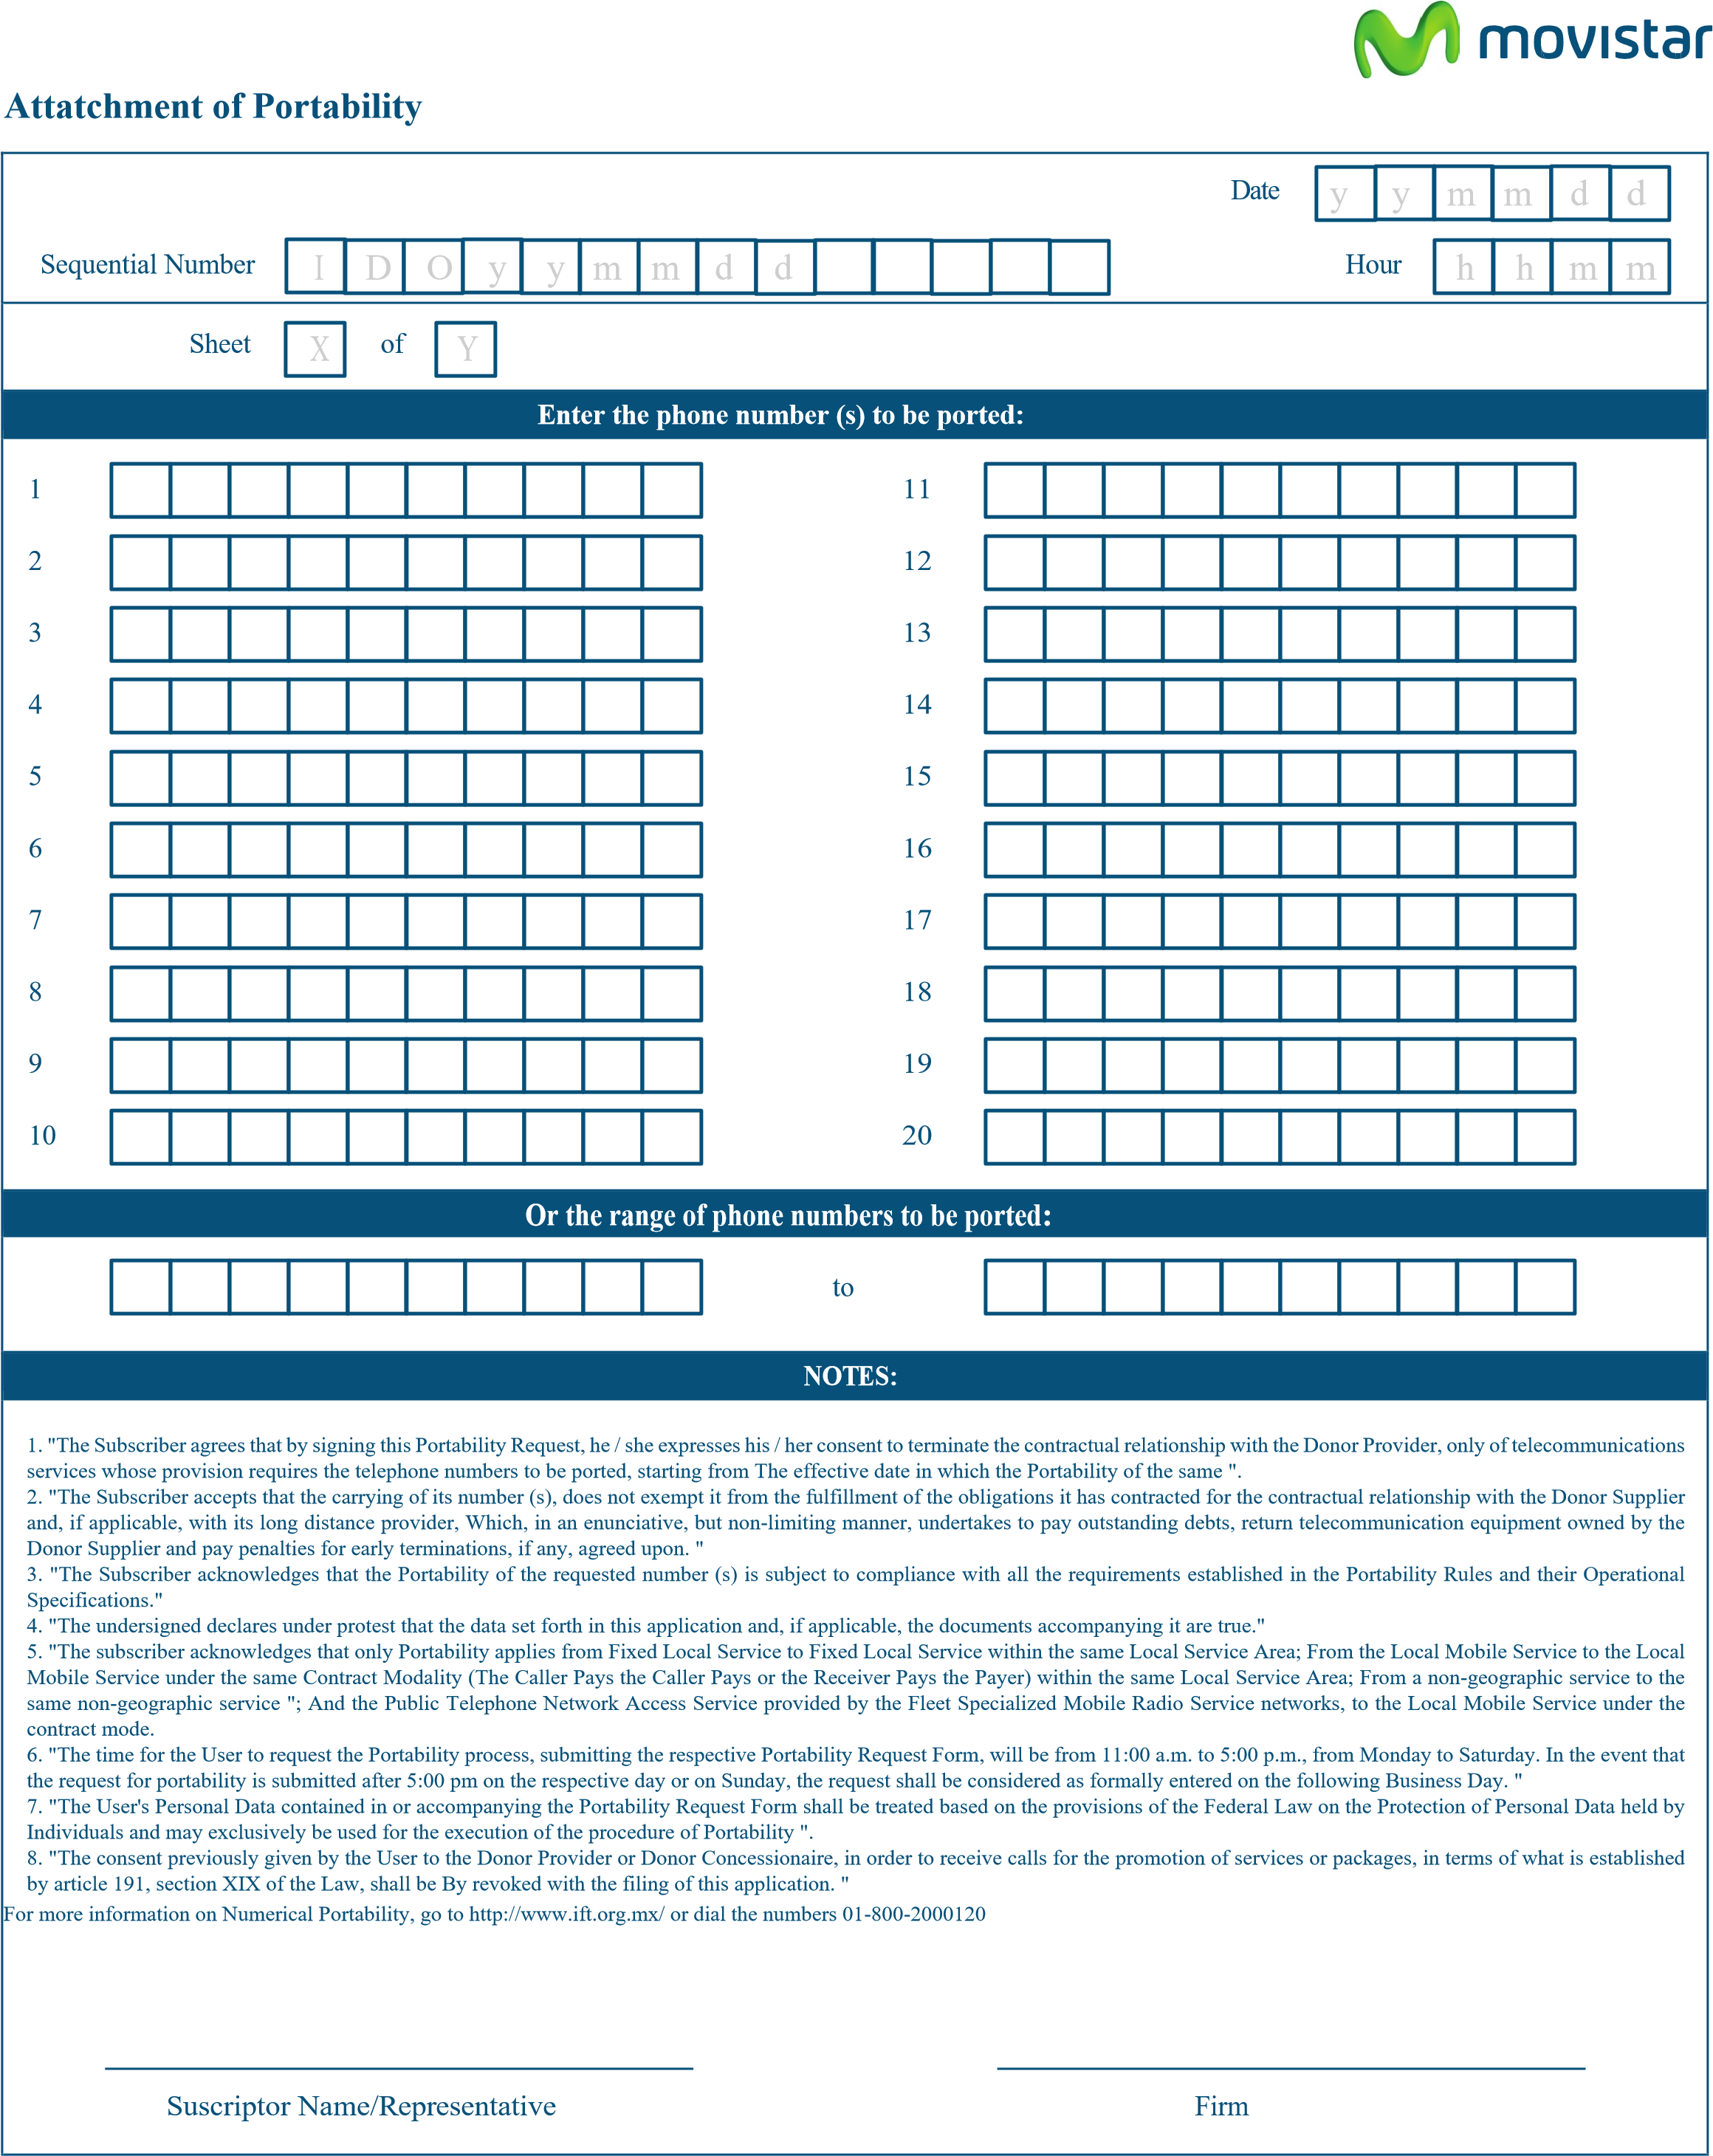
ZOOM CUUSTOMERS SIGNATURE
ZOOM CUSTOMERS PRINTED NAME

Movistar with address in Prolongación Paseo de la Reforma No. 1200, Colonia Cruz Manca, Delegation Cuajimalpa, C.P. 05349, Mexico, D.F .; Will treat your personal data with the purpose of carrying out the necessary activities for the portability process as well as the efforts to fulfill the obligations arising from any legal and commercial relationship that we establish in connection with the rendering of our services. Also, for marketing, advertising and / or commercial prospecting purposes. For more information about the treatment and rights that attend you access our Integral Privacy Notice in http://www.movistar.com.mx/Legales-Aviso-de-privacidad.

