Process Description-

We have a copy of standard porting LOA for porting geographic and numbers as following for a walkthrough with details-

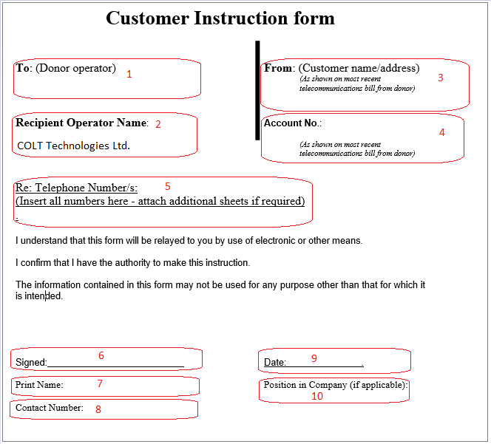

Note: Please keep a copy of latest invoice handy while filling out the LOA with following inputs required.

- To (Donor Operator) – Put the name of the customer’s current communication provider as per invoice.
- Recipient Operator Name – Keep this ‘unchanged’. This has COLT details as gaining communication provider.
- From – Put the customer name and registered address as per mentioned in latest invoice.
- Account No. - This is the account number of customer registered with losing communication provider.
- Telephone Number/s – This shall contain the details of numbers customer wishes to port.
- Signed – Customer must duly sign the LOA at this field.
- Print Name – Keep the name of authorised person signing the LOA at customer end.
- Contact Number – Put the contact details of the requestor for reference.
- Date – Enter the date on which customer signs the LOA. In general, customer LOA is valid for 90 days from the signed date
- Position in Company – Mention the job title of the contact person at customer site being authorised to request number portability on Company’s behalf.

