Process Description-

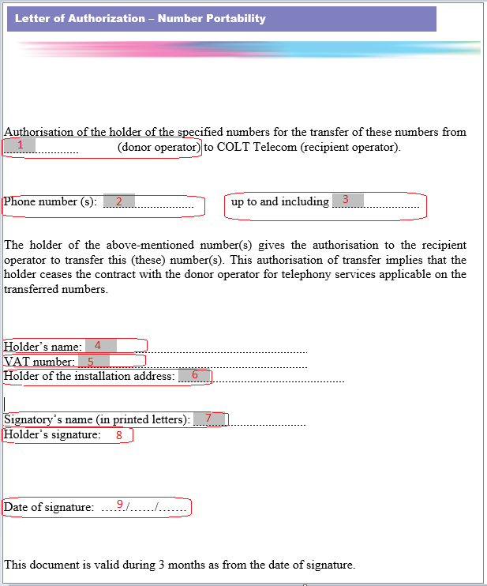

Note: Please keep a copy of latest invoice handy while filling out the LOA with following inputs required.

- Donor Operator – Put the name of the customer’s current communication provider as per invoice.
Note: This must be verified by customer with operator name information available on public domain at https://www.crdc.be/

- Phone Number(s) – This shall contain the details of start number range customer wishes to port.
- Phone Number(s) – This shall contain the details of end number range customer wishes to port.
- Holder’s Name - Put the name of the customer as per registered with losing communication provider.
- VAT Number – Enter the VAT number details from the invoice.
- Holder of the Installation address – Enter the details of installation address from which numbers are required to be ported.
- Signatory’s Name – Mention the full name of person signing the LOA.
- Holder’s Signature - This contact person at customer site is authorised to request number portability on Company’s behalf.
- Date of Signature – Enter the date on which customer signs the LOA. In general, customer LOA is valid for 90 days from the signed date.

